Alarming system for cyclones

**Why?**

* Present systems are not so efficient (though there is significant improvement) (The average operational forecast error for 24 hours track forecast is about 140 km and landfall is 80 km)
* India is taking help from America(NOAA) (Why not become self-independent) – Sometimes India need to buy data/images from commercial sites for which annual expenditure varies from 10 to 20 crores annually (source - http://www.moes.gov.in/programmes/satellite-meterology)
* Need is to improve the skill for track and intensity prediction of tropical cyclones by utilizing the high spatial and temporal observations
* Meteorogical department has worked in collaboration with IIT Delhi, IIT Odisha, IIT KGP, IISc etc.

On basis of constellation of 8 small satellites – **CYGNSS**

Science behind - analyze reflected GPS signals from water surfaces shaped by hurricane-associated winds. CYGNSS measures the ocean surface wind field associated with tropical cyclones by combining the all-weather performance of GPS-based bistatic scatterometry.

It will receive both direct and reflected signals from GPS (Global Positioning System) satellites.

The direct signals pinpoint CYGNSS observatory positions, while the reflected signals respond to ocean surface roughness, from which wind speed is retrieved.

Carry a delay-Doppler mapping instrument consisting of a multi-channel GPS receiver, low-gain zenith antennas, and high-gain nadir antenna.

The mission will study the relationship between ocean surface properties, moist atmospheric thermodynamics, radiation and convective dynamics to determine how a tropical cyclone forms and whether or not it will strengthen, and if so by how much.

inclination of 35 deg.

I am rejecting above idea because CYNGSS is a constellation of 8 small satellites and thus power & volume requirements are more.

**TROPICS**

Constellation of 3U CubeSats

Microwave measurements over the tropics that can be used to observe the thermodynamics of the troposphere and precipitation structure for storm systems at the mesoscale and synoptic scale over the entire storm lifecycle ( measuring temperature and water-vapor profiles at low altitudes).

radiometer scanning across the satellite track at 30 RPM to provide temperature profiles using seven channels near the 118.75 GHz oxygen absorption line, water vapor profiles using 3 channels near the 183 GHz water vapor absorption line, imagery in a single channel near 90 GHz for precipitation measurements, and a single channel at 206 GHz for cloud ice measurements.

600 km altitude (550±50 km tolerance), 30° inclination (±3° tolerance)

**MicroMAS-2 CubeSat (under TROPICS)**

12-channel passive microwave spectrometer providing imagery near 90 and 206 GHz, temperature sounding near 118 GHz, and moisture sounding near 183 GHz.

1 U & 3.75W for payload (radiometer part rotates at rate of 30 RPM)

10*10*34 cm

3.8 kg

9.6 W

16kbps data rate

0.2 deg. Pointing accuracy

More than 12 months lifetime

COTS for low cost

**Help factor –** Manufacurer of **MicroMas1** are involved in the development and testing of ultra-compact radiometer component technologies that would enable the realization of a high-performance, multi-band sounder that would conform to the 1U CubeSat form factor requirements

Specifications of MicroMas1

* Near-equatorial orbit
* 3U – 1U for payload & 2U for bus
* 34*10*10 cm
* 4.5 kg
* ~500-km(475-600 km) orbit altitude
* Inclination of 20-60 deg.
* 0.5-degree pointing knowledge
* 1-year mission lifetime
* 50 rpm
* 16 kbps downlink
* 12 W (avg) power

**Payload developed by Lincoln-led team (MIT)**

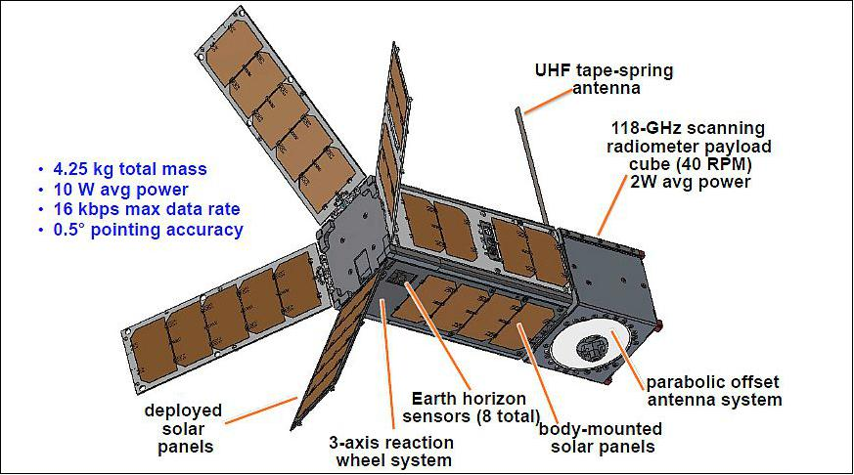

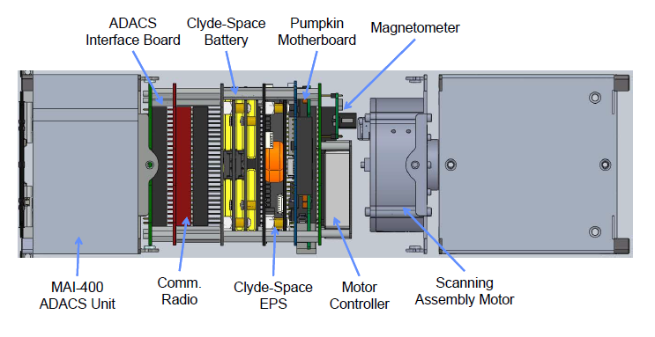

Specifications of Radiometer

* 8 channels near 118.75-GHz oxygen line
* 1 window channel
* Cross-track scan
* Spatial Nyquist sampling
* 2.4-degree FWHM antenna beam
* 95% beam efficiency
* 1-2 W (avg)
* 0.3 K NEDT
* Noise diode, earth limb, and cold sky calibration
* 1 K calibration accuracy

Questions:

1. How much are we improving the present system (study about existing satellites for meteorology in India & compare it with TROPICS)?
2. Can resolution obtained using TROPICS be achieved with single satellite?
3. What is source of microwave radiations?
4. Is getting the instrument required possible in India?

Answers:

1. The existing architecture of few, high-cost platforms, infrequently view the same earth area which can miss rapid changes in the strength and direction of evolving storms thus degrading forecast accuracy. Complements GPM, CYGNSS, and GOES-R missions with high refresh, near-all-weather measurements of precipitation and thermodynamic structure. (TROPICS will provide 30-minute median refresh rate at all longitudes and +/-40° latitude)
2. MicroMas provides a nadir resolution of ~20 km while the best current satellite spatial resolution (for meteorological purpose) are ~50 km on AMSU (Advanced Microwave Sounding Unit), ~25 km on SSMIS (Special Sensor Microwave Imager Sounder), and ~33 km on ATMS (Advanced Technology Microwave Sounder) launched on Suomi NPP on Oct. 28, 2011. None of these satellites revisit any latitude lower than 50° more than twice daily (~12-hour intervals). MicroMAS-1, because of its low inclination orbit and low altitude, will not only revisit most hurricanes at least twice daily but sometimes may visit two or even three times daily at ~100 minute intervals for many storms in the outer 8º latitude bands, thus revealing for the first time the character of rapid thermal variations of a large variety of storms
3. The source of microwave radiations are oxygen atoms present in atmosphere.
4. **Sent mail waiting for reply (Prof. Varun gave reply in negative) – still a big doubt**

Three meteorological satellites [Kalpana-1](http://www.isro.gov.in/Spacecraft/kalpana-1), [INSAT-3A](http://www.isro.gov.in/Spacecraft/insat-3a) and [INSAT-3D](http://www.isro.gov.in/Spacecraft/insat-3d) in the geosynchronous orbit India has launched Megha Tropiques(weather satellite) on 12 October 2011.

I have started thinking that this payload is unnecessary as a satellite named SCATsat1 was launched on 26 Sept. 2016 whose main purpose was weather forecasting, cyclone detection and tracking. It is a gap-filler mission between OceanSat2 and 3.

But then I realized that all the Indian meteorological satellites are large one (not a single cubesat). So, it will be a technological demonstration that such large cost missions can be substituted by cubesats ( a real & interesting challenge – more challenging because MicroMas 1 failed in the sense it was never been able to send payload data).Also in India till now there is no constellation. Constellation will result in more spatial & temporal observations. If we show that cyclone prediction is possible from small satellites, we can get permission from ISRO to form a constellation & other colleges can build their own satellite for this constellation (our social goal). – For now our satellite will be technological demonstration that Indian students too can build cubesats capable of predicting cyclones.

I have answered all other questions & question that is left unanswered is how to procure instrument. Let believe that I could not get it.

Now how it will affect my payload?

Which jobs was it doing?

1. Taking images at 90(precipation) & 206(cloud-ice) GHz
2. Temperature through oxygen-spectra at 118.75 GHz
3. Moisture through water-vapour spectra at 183 GHz

How those jobs can be done by other methods?

I am not finding (a) that much imp. Then also (b) & (c) are left.

Lets say that I substitute oxygen with some other atom whose spectra falls in RGB & can be used to find temp.

New questions arising:

1. Which atoms?
2. Can RGB be used to measure temp.(its frequency is 430-770 THz !!!)? How much attenuation is it facing while passing through atmosphere? Can it give reliable data even after so much attenuation?
3. Are there atoms/molecules whose spectra can be related to moisture content?

Answer - Substitution is not possible.

So, I need to find alternative methods for measuring temperature & humidity & see that they fit on a cubesat platform.

Our main aim is to measure temperature from surface to stratosphere.

After all studies, I came to conclusion there is no method of measuring moisture content except using microwave or infrared radiometer.